**PROJECT REPORT**

**ANALYSING HOUSING PRICEs IN**

**METROPOLITAN AREAS**

**TEAM DETAILS:**

**TEAM LEADER : K.NITHYA**

**TEAM MEMBERS : S.BOOMIKA, G.NIVETHA, S.DHANALAKSHMI**

**1. INTRODUCTION:**

**1.1 OVERVIEW:**

**FIRST I created an EMPTHY MAP. A map has four quadrants-says, thinks, does and feels. Next, How do I prepare for tableau interview. How do you measure the talent management success. What are the critical issues that a talent scorecard should measure? This are all things I shown in my four Quadrants. Next I created BRAIN STORM. My team members give some idea for this brainstorm. Then I created my data Analysis Dashboard and story next I published my dashboard and story in the Tableau public.**

**1.2 PURPOSE:**

**In the mortgage market, the range and flexibility of Products have increased. Lock in clauses in Mortgage contracts have become increasingly rare. More firms now offer variable-repayment mortgages, the faculty for lump-sum withdrawals against net housing equity, and flexible mortgage products, which allow the borrower to change the principal at low or zero transactions cost.**

**2. Problem Definition & Design Thinking**

**2.1 EMPATHY MAP:**

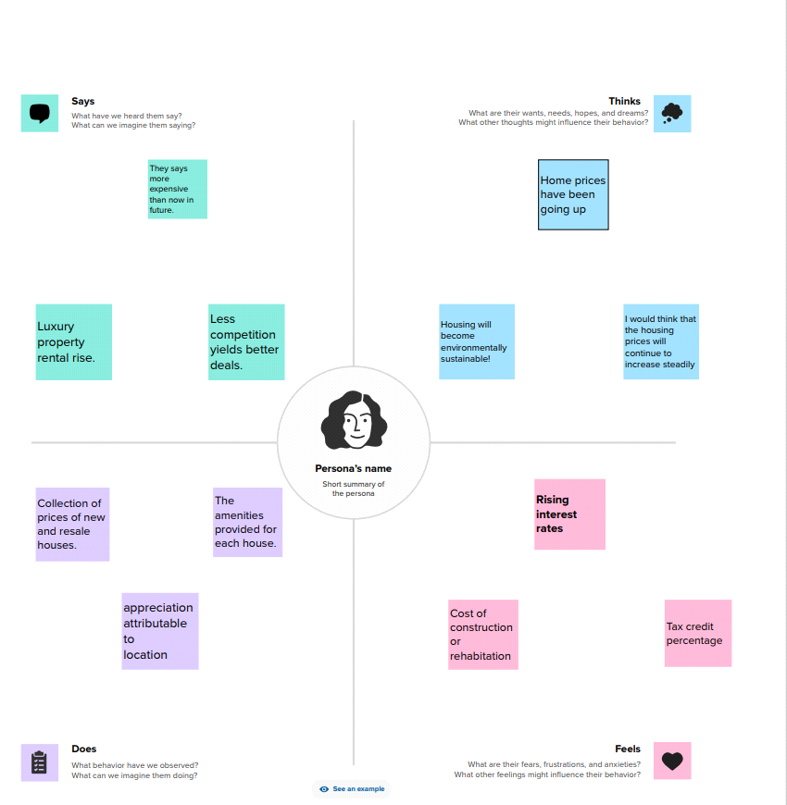

**2.2 Ideation & Brainstorming Map**

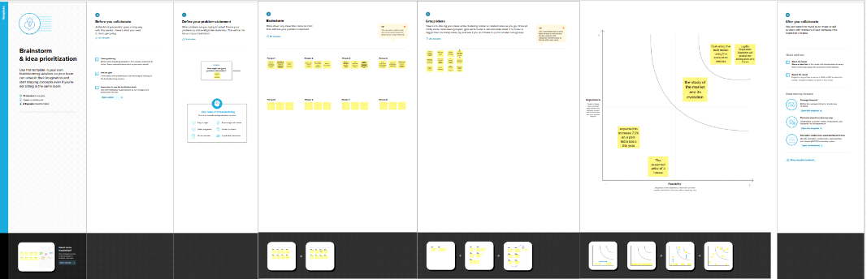

**3. RESULT:**

**Dashboard 1:**

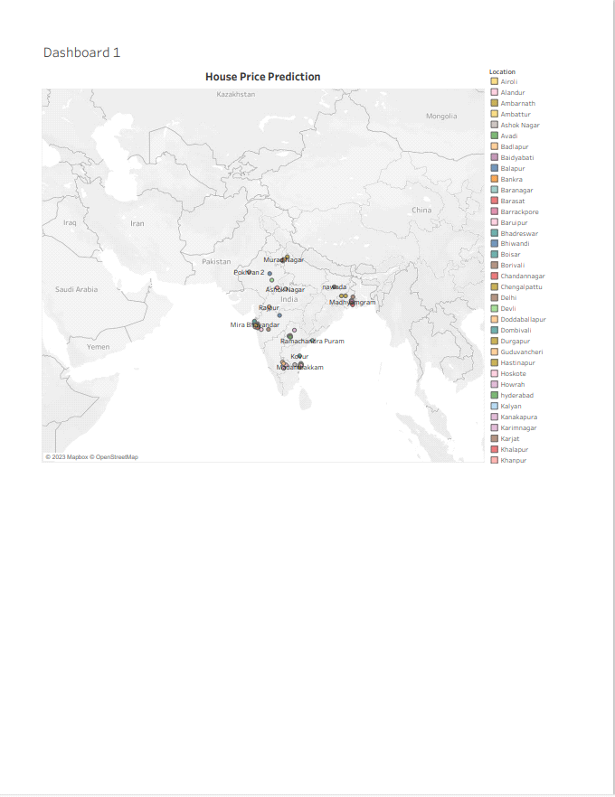

**Dashboard 2:**

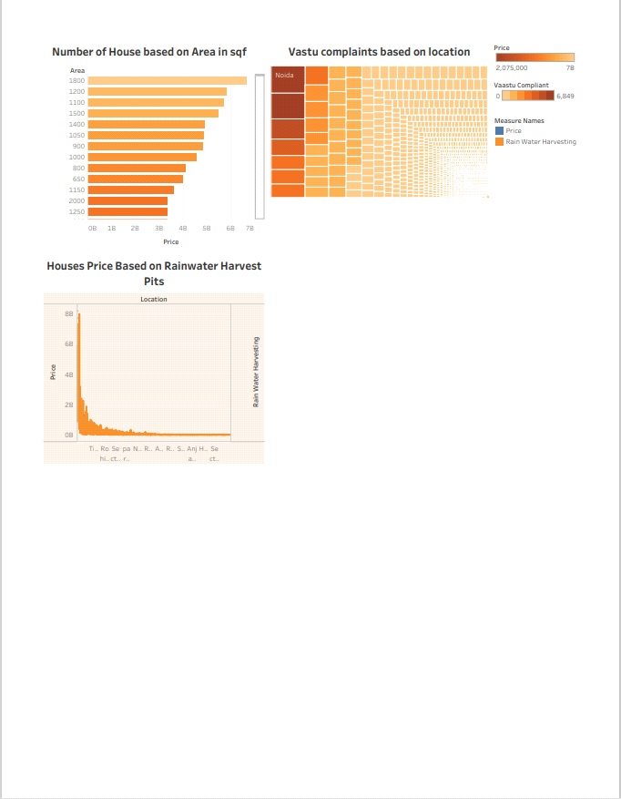

**Dashboard 3:**

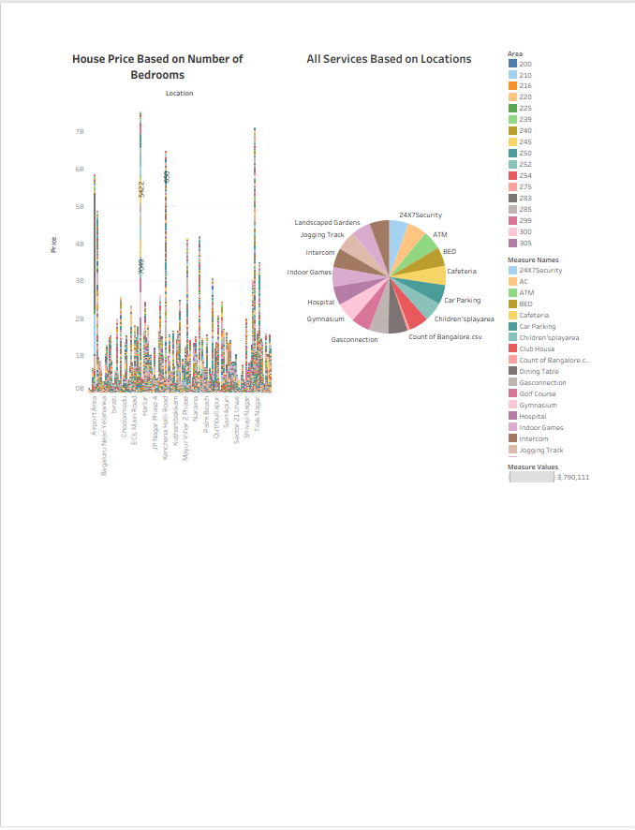

**Dashboard 4:**

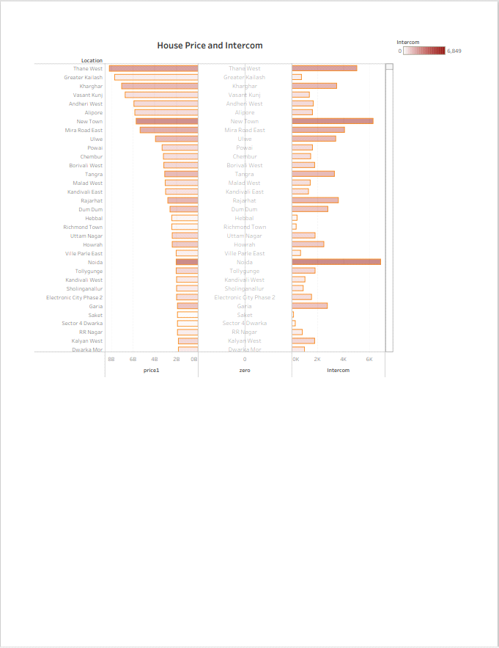

**STORY:**

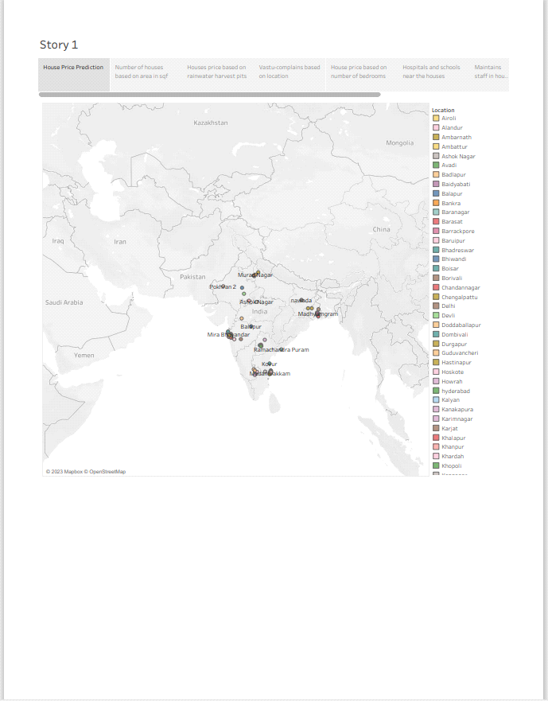

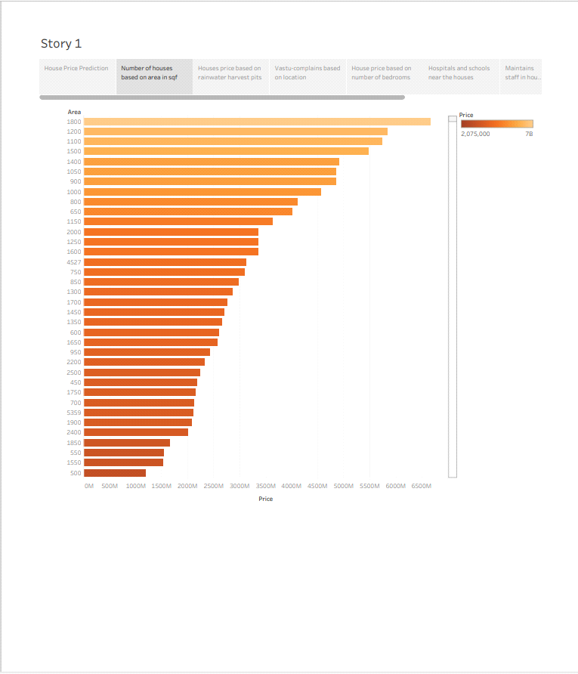

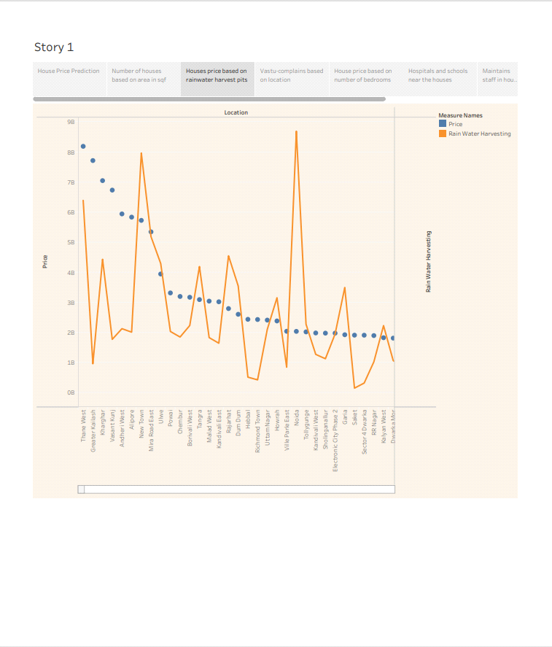

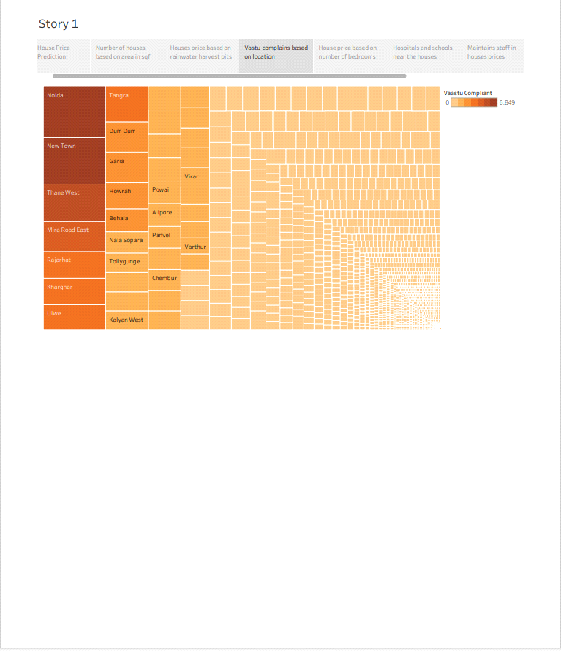



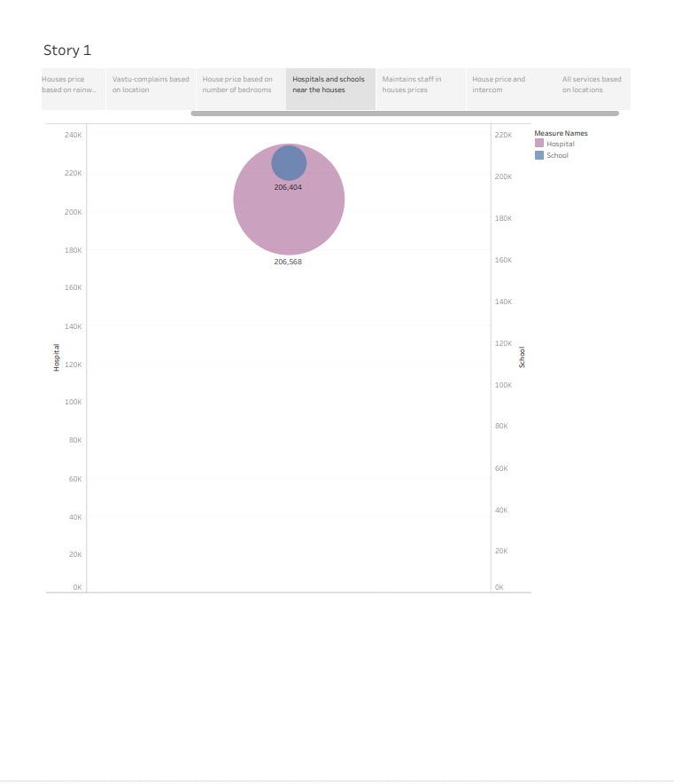

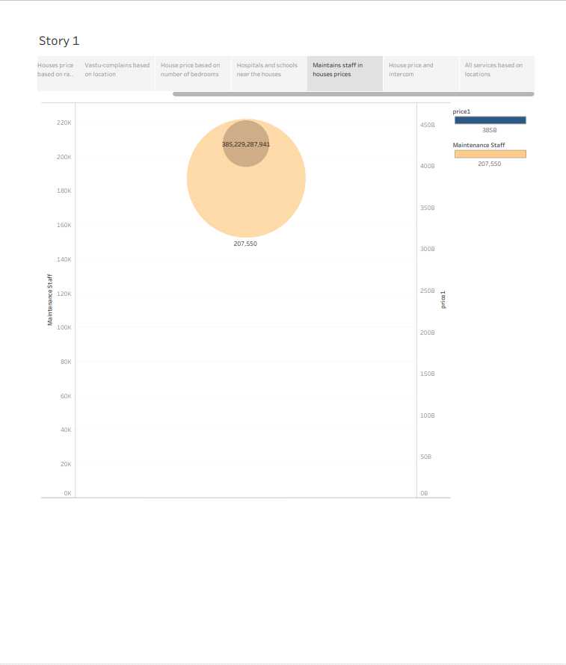

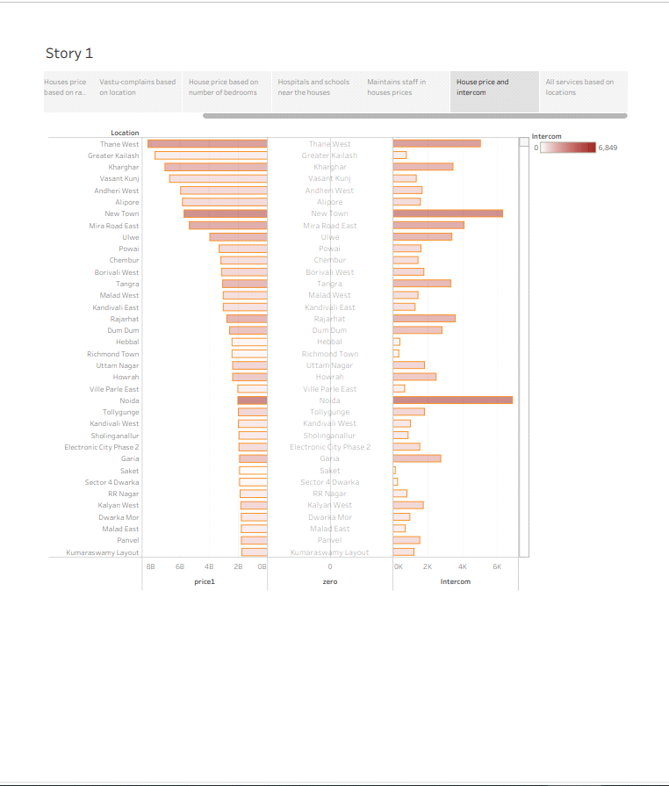

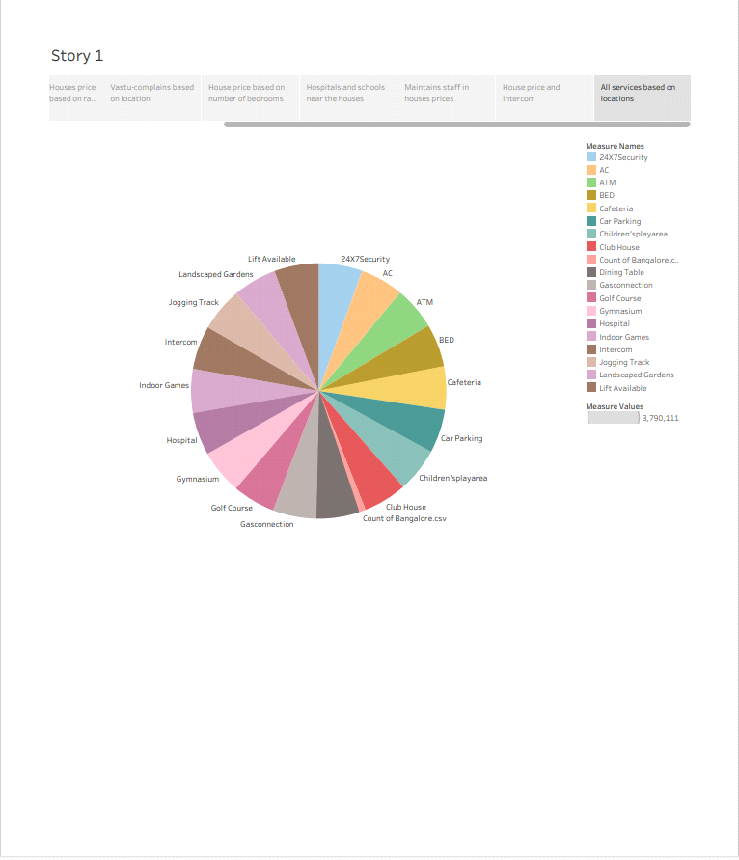

**4. ADVANTAGES AND DISADVANTAGES:**

**Advantages:**

* **Flexible use.**
* **One lump sum.**
* **Fast Funding.**
* **They can help build your credit score.**
* **Higher Borrowing Limit than a credit card.**
* **Lower Interest Rates than a credit card.**
* **Flexible Repayment Terms.**

**Disadvantages:**

* **Imbalance between supply and demand.**
* **Use materials like asbestos, lead, etc.,**
* **Shortages.**
* **Extra charges.**
* **It doesnt predict future prices of the houses mentioned by the customer.**
* **Overcrowding, cost burden, and substandard conditions.**

**5. APPLICATIONS:**

**House price prediction can help the developer determine the selling price of a house and can help the customer to arrange the right time to purchase a house. There are three factors that influence the price of a house which include physical conditions, concept and location.**

**6. CONCLUSION:**

**Prediction house prices are expected to help people who plan to buy a house so they can know the price range in the future, then they can plan their finance well. In addition, house price predictions are also beneficial for property investors to know the trend of housing prices in a certain location.**

**7. FUTURE SCOPE:**

**It encompasses various segments**

* **Including residential**
* **Commercial**
* **Retail**
* **Hospitality and**
* **Industrial properties.**